UNIVERSITY OF LEICESTER

SOFTWARE MEASUREMENT
AND
QUALITY ASSURANCE

GARIGIPATI YASWANTH SAI
KONGITHALA ANJANI DEVI
ORUGANTI HARSHA VARDHAN
SHAIK SHEENA

Section A

Introduction
This project has been developed for this assessment to design and implement an Examination Paper Management System that supports the preparation, review, storage, and validation of examination papers in an academic setting. The software handles the full examination workflow, including question creation, exam paper drafting, review and approval, secure file storage, version control, and controlled access. By replacing manual handling with a structured software process, the system reduces errors, avoids confusion between versions, and ensures that every stage of exam preparation follows a clear and traceable path [1].
The system is implemented as a file-based back-end application rather than a web or database-driven system. This design choice supports clear logic flow, simple data handling, and easy verification of program behaviour. Each feature is implemented as a separate module with a specific responsibility, such as question bank handling, exam draft processing, review checks, encryption, backup, and audit logging. This separation of functionality improves readability of the code, reduces dependency between components, and allows controlled modification of individual features without affecting the full system [3].
Software planning is carried out using a structured group-based approach. The development work is divided into sprints, and each sprint contains clearly defined user stories. Each user story represents a single system feature and is assigned to specific group members. This approach supports task clarity, responsibility sharing, and progress tracking. Planning artefacts such as effort estimation, scheduling, and dependency identification are prepared to guide development and to ensure that implementation aligns with assessment requirements and time constraints [1].
The implementation follows a modular back-end structure where all data is stored and processed through structured files. Validation checks are applied at each stage to ensure that incomplete, incorrect, or unauthorised exam data does not move forward in the workflow. Encryption and access control logic protect sensitive examination content, while audit logs record key actions for accountability. This design supports correctness, traceability, and predictable execution of the software [4].
Testing is integrated throughout development to confirm that the software behaves as defined by the user stories. Black-box testing verifies that each feature produces correct outputs for given inputs, while white-box testing examines internal logic and execution paths. Symbolic execution and concolic testing are applied to explore alternative paths and identify hidden logic errors. These testing methods improve confidence in functional correctness and code reliability [5].

Software Planning and Design
Software planning and design for the Examination Paper Management System follow a structured and disciplined approach that aligns with established software engineering practices. Planning activities define the scope of functionality, allocation of responsibilities, scheduling of development tasks, and estimation of effort and cost. Design activities focus on translating functional requirements into well-defined back-end modules with clear interfaces and controlled data flow. This combination of planning and design supports predictability, traceability, and quality throughout the development lifecycle [1].
The planning process begins with the identification of functional requirements expressed as user stories. Each user story represents a clearly defined system capability that delivers observable value within the examination management process. User stories describe actions such as question creation, exam draft preparation, review workflows, secure storage, and audit logging. These stories form the basis for sprint planning, task allocation, estimation, and verification. The use of user stories supports requirements clarity and reduces ambiguity by linking each requirement directly to an implemented function within the system [3].
Sprint-based planning divides development work into three time-boxed iterations with defined start and end dates. The first sprint focuses on core functional development, including question bank management, exam draft creation, review handling, and basic storage operations. The second sprint extends functionality through advanced logic such as categorisation, duplicate detection, encryption, version control, and backup mechanisms. The third sprint concentrates exclusively on system-wide testing, validation, and coverage measurement. This incremental approach supports early delivery of working functionality and controlled integration of advanced features [2].
Responsibility allocation ensures that each team member contributes to both development and quality-related activities. Question bank functionality, including creation, modification, validation, categorisation, and serialization, maps to a defined set of user stories and corresponding back-end functions. Exam draft management responsibilities include draft creation, metadata handling, marks calculation, difficulty validation, and version control. Review and approval workflows cover draft evaluation, comment management, approval decisions, audit logging, and status tracking. Storage and security responsibilities include file organisation, encryption, comparison of exam papers, backup creation, and restoration. This allocation promotes balanced workload distribution and clear ownership of system components [4].
Each user story maps directly to one or more functions implemented within the back-end codebase. This mapping establishes traceability between requirements and implementation, enabling verification that all planned functionality is realised in code. Function-level traceability also supports testing and coverage measurement by clearly identifying which functions correspond to specific user stories. Such traceability is essential for disciplined software development and aligns with recommended practices for requirements management and verification [7].
Estimation of effort and schedule relies on formal planning techniques rather than ad hoc judgment. Story points provide a relative measure of complexity and effort for each user story. Aggregation of story points across sprints supports velocity calculation, which indicates the amount of work completed within a sprint. Velocity trends provide insight into development progress and support realistic planning for subsequent iterations. Burndown charts visualise remaining work over time and offer a clear representation of sprint progress relative to planned objectives [2].
Program Evaluation and Review Technique supports schedule analysis by modelling task dependencies, expected durations, and critical activities. Activities derived from grouped user stories form the basis of the PERT network. Expected time calculations use optimistic, most likely, and pessimistic estimates to reflect uncertainty in task duration. Forward and backward pass calculations identify earliest and latest start times, slack values, and the critical path. Identification of the critical path highlights activities that directly influence total project duration and require close monitoring [1].
Cost estimation applies established software cost models to quantify development effort and schedule. The COCOMO I model estimates effort and development time based on system size measured in lines of code. This estimation supports understanding of resource requirements and provides a baseline for cost analysis. Advanced estimation using
Earned Value Management provides quantitative insight into project performance by integrating scope, schedule, and cost information. Planned value represents scheduled work, earned value represents completed work, and actual cost represents effort expended. Comparison of these measures highlights schedule variance and cost variance, enabling objective assessment of project status. The application of EVM principles supports disciplined monitoring and control during development [2].
Overall, software planning and design establish a structured foundation for the Examination Paper Management System. The use of user stories, sprint planning, formal estimation techniques, and traceable design ensures alignment between requirements, implementation, and verification. This approach reflects accepted software engineering practice and supports predictable delivery, quality assurance, and process maturity [3], [8].

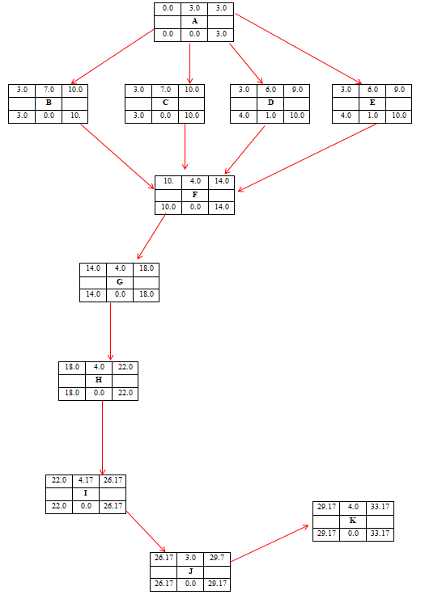
Figure1: PERT Diagram

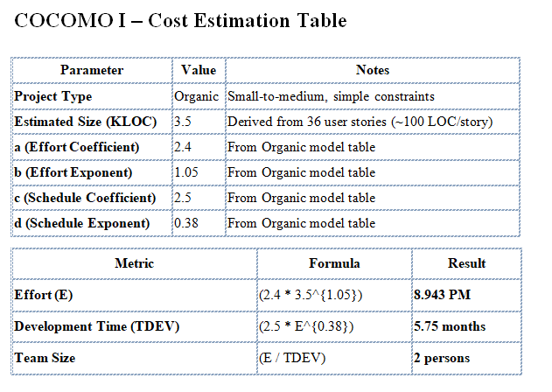
Figure2: COCOMO 1 Model

Implementation (Back-End)

The back-end implementation of the Examination Paper Management System follows a modular and file-based approach that supports clarity, traceability, and controlled execution. The implementation focuses on core examination workflows that include question bank handling, exam draft management, review and approval control, secure storage, encryption, backup, and audit logging. All functionality operates through structured functions with explicit input validation and predictable output, supporting correctness and ease of verification [3].
The overall back-end structure uses a menu-driven control flow that separates major functional areas into distinct modules. Each module encapsulates related operations and accesses persistent data through structured files. Data persistence relies on JSON files for readability and traceability, and serialized files for efficient storage of structured objects. This approach avoids database dependencies and supports direct inspection of stored data, which aligns with principles of transparency and controlled data handling in software engineering practice [4].
The question bank module manages the lifecycle of examination questions. Question creation functions capture essential attributes such as question text, options, correct answer, topic, and difficulty level. Validation logic ensures that mandatory fields are present and correctly formatted before data storage. Editing and deletion functions maintain accuracy and relevance of stored questions. Categorisation functions group questions by topic and difficulty, supporting balanced exam paper creation. Duplicate detection logic compares new entries with existing data to prevent repetition. Serialization functions store the question bank in a compact file format for persistence across executions.
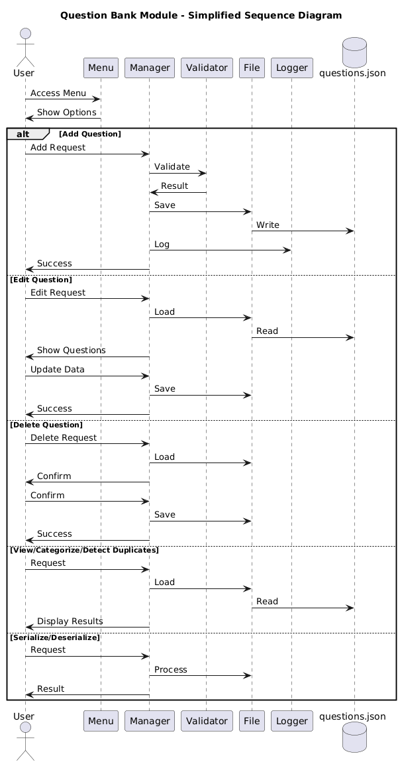
Figure 3: Question Bank Module Flow Diagram
The exam draft module supports structured creation and management of examination papers. Draft creation functions assemble selected questions into an exam structure while capturing metadata such as course code and duration. Automatic mark calculation logic aggregates marks from individual questions to ensure consistency. Difficulty validation logic checks the distribution of questions to maintain balance. Version control functions save successive revisions of drafts and support retrieval of earlier versions for comparison or modification. These features ensure controlled evolution of examination papers and reduce the risk of unintended changes [3].
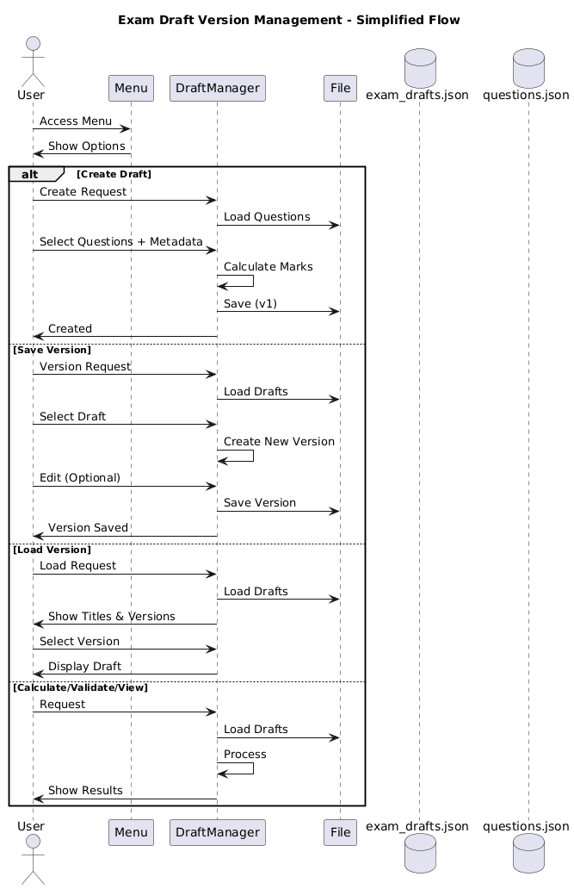
Figure 4: Exam Draft Version Management Flow
The review and approval module enforces a clear workflow for examination validation. Review functions allow examination papers to be inspected for correctness and completeness. Comment management functions record structured feedback linked to specific drafts and versions. Approval and rejection logic updates review status and controls progression to finalisation. Audit logging functions record reviewer actions, timestamps, and outcomes in a dedicated log file. This workflow ensures accountability and traceability across review stages, supporting disciplined process control [7].
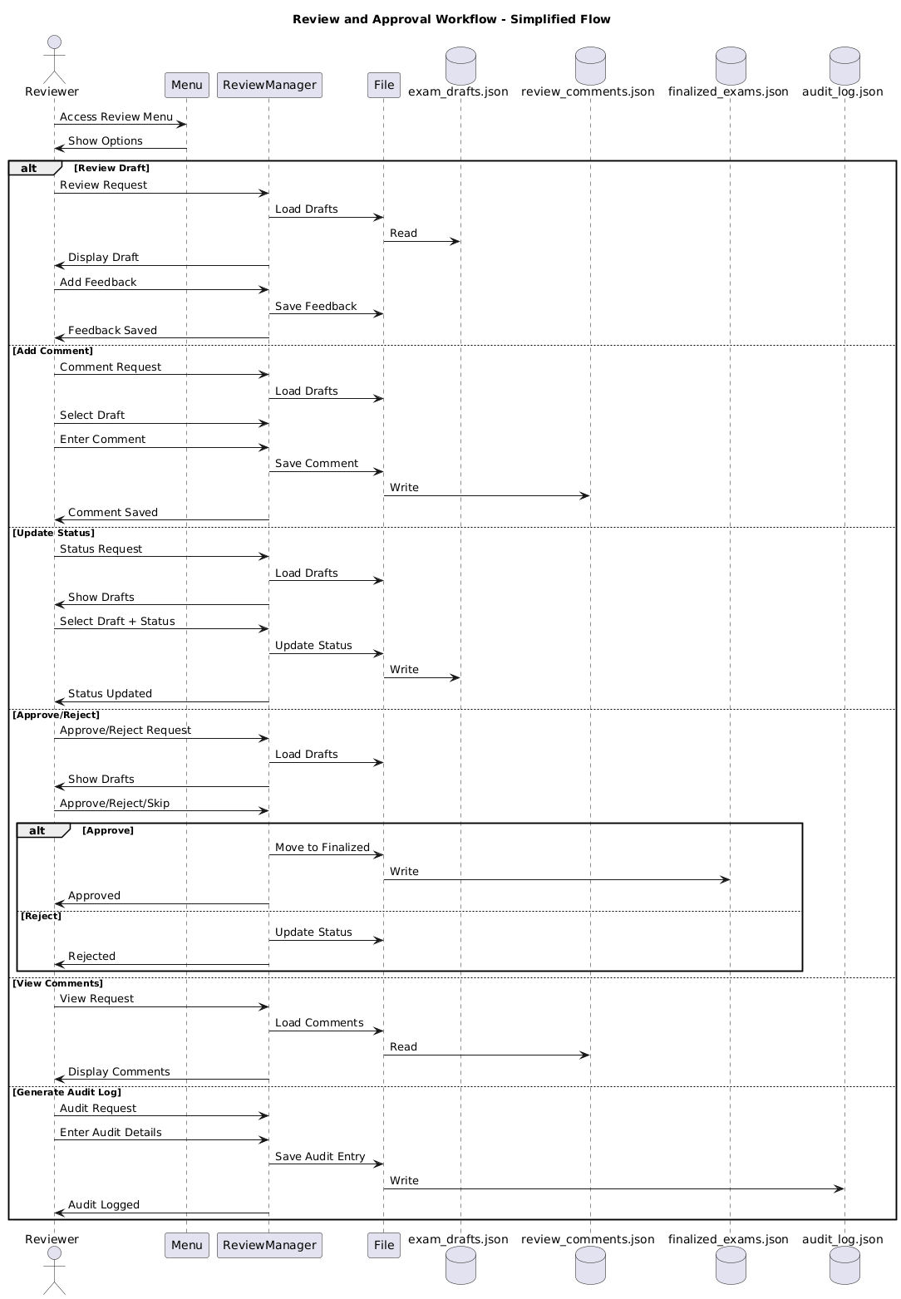
Figure 5: Review and Approval Workflow Diagram
The storage and security module manages finalised examination papers and related safeguards. Storage functions organise files into structured directories based on logical attributes such as course or session. Encryption logic protects stored examination content by transforming data before persistence, ensuring confidentiality during storage. Comparison functions analyse two examination papers to identify differences in content or structure. Backup functions create timestamped copies of stored data, while restoration functions support recovery from backup files. These mechanisms collectively support data protection, recovery, and controlled access [4].
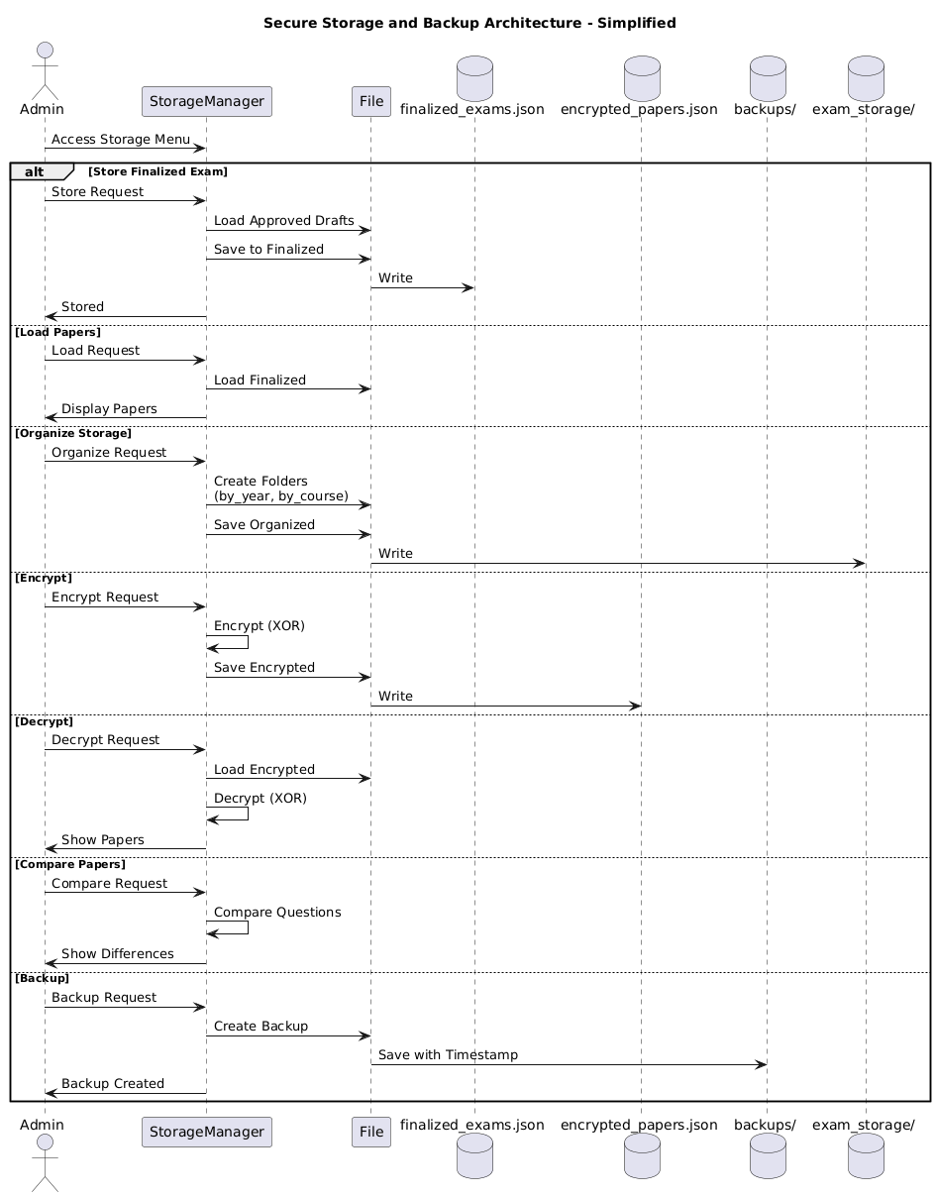
Figure 6: Secure Storage and Backup Workflow
Cross-cutting utility functions support the reliability of the back-end implementation. File-handling utilities ensure required files exist before access and handle read and write operations safely. Validation utilities enforce structural correctness of data objects across modules. Logging utilities record system activities in both structured logs and human-readable formats. These supporting functions reduce duplication of logic and improve maintainability by centralising common behaviour [3].
The back-end design demonstrates clear separation of concerns and strong alignment between planned user stories and implemented functions. Each user story maps directly to one or more back-end functions, enabling precise traceability between requirements and code. This mapping supports later testing and coverage measurement by clearly identifying functional boundaries. The implementation adheres to structured programming principles and reflects accepted software engineering practices for small to medium-scale systems [4], [8].

Testing and Test Coverage Measurement
Testing and test coverage measurement validate functional correctness, internal logic, and execution behaviour of the Examination Paper Management System. Testing activities align with completed back-end modules and implemented user stories, and execution takes place after development activities conclude. The adopted testing strategy combines specification-based black-box testing, structural white-box testing, and advanced path analysis through symbolic execution and concolic testing. Numerical coverage measurement provides objective evidence of exercised code paths at the module level [3], [4].
4.1 Overview of the Testing Approach
The testing approach follows a layered structure that progresses from external behaviour validation to internal logic verification and execution path exploration. Specification-based tests validate observable system behaviour against expected outcomes without reference to internal implementation. Structural tests validate statement and branch execution within the code. Symbolic execution and concolic testing extend coverage by analysing conditional logic and systematically exercising alternative execution paths. Automated test execution ensures repeatability and halts execution upon failure, maintaining reliability of reported results [4], [5].

4.2 Black-Box Testing
Black-box testing applies specification-based validation using the Python unittest framework. Test cases derive directly from functional specifications and user stories. The black-box test suite consists of one hundred and ten test methods distributed across twenty-three test files under the specification-based testing directory. Test execution uses unittest discovery, which automatically identifies and executes all test cases within the defined structure.
Sheena contributes to black-box testing of the question bank module. Test cases validate question creation, modification, deletion, validation, categorisation, duplicate detection, and serialization behaviour. These tests confirm that question-related functions behave correctly for valid and invalid inputs.
Anjani contributes to black-box testing of the exam draft module. Test cases validate exam draft creation, automatic mark calculation, difficulty distribution validation, draft version saving, and draft retrieval. These tests ensure that draft management logic conforms to defined specifications.
Harsha Vardhan contributes to black-box testing of the review module. Test cases validate review workflows, comment handling, review status updates, approval and rejection behaviour, versioned review storage, and audit log generation. These tests confirm correct execution of review decisions and workflow transitions.
Ak Gy contributes to black-box testing of the storage module. Test cases validate finalised exam storage, retrieval, file organisation, encryption and decryption, comparison of exam papers, and backup creation. These tests ensure correct behaviour of storage and security mechanisms.
All black-box test cases execute successfully. The unittest discovery process completes without interruption, and coverage report generation proceeds only after successful test execution, confirming absence of failing test cases.
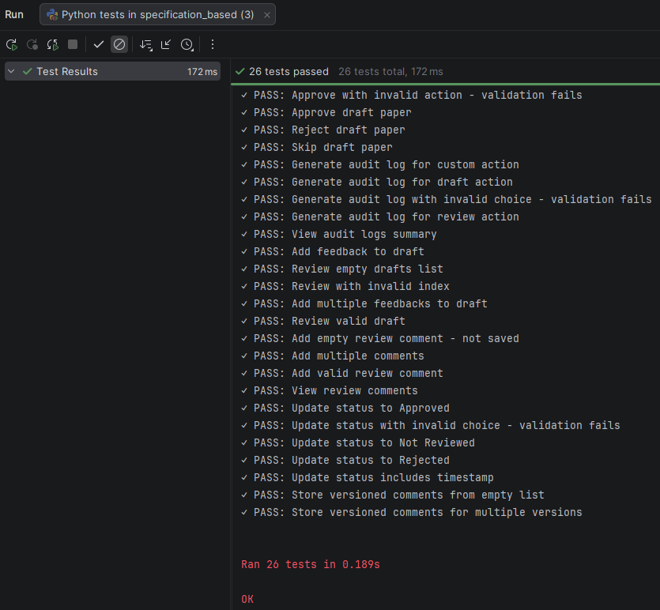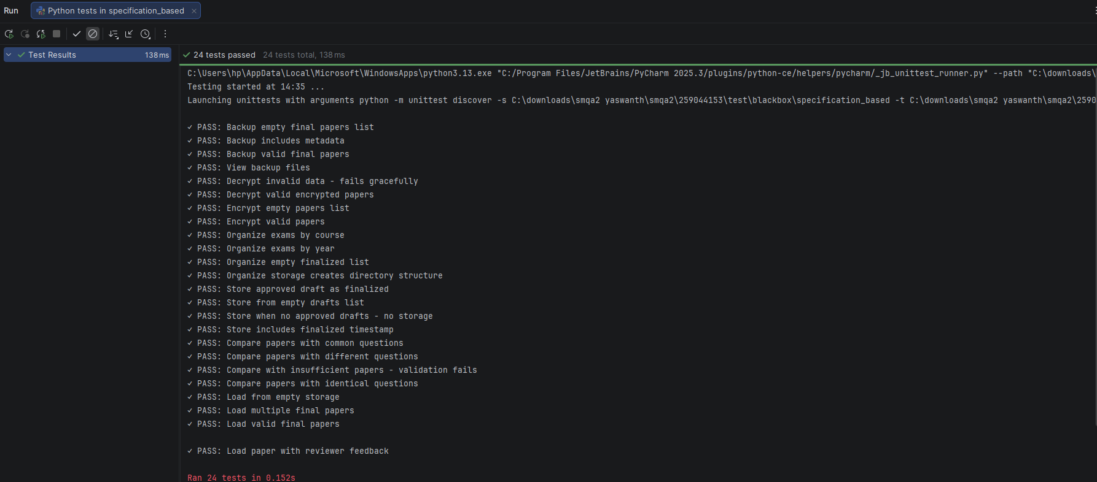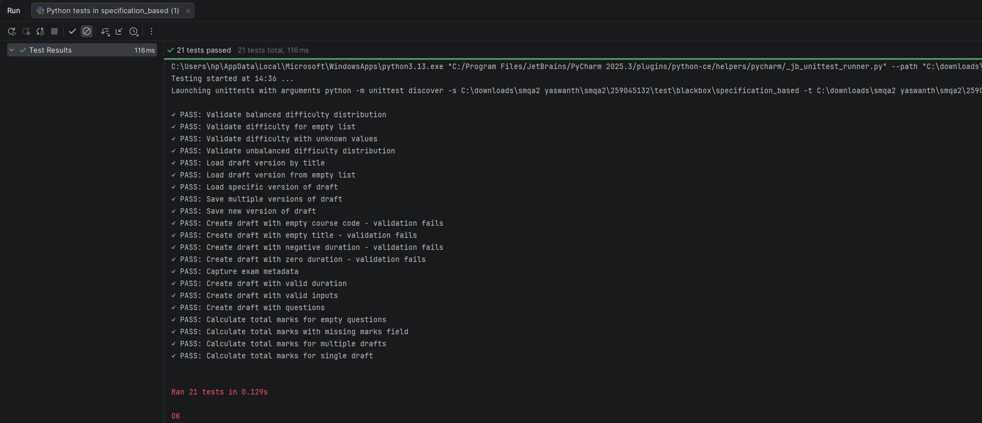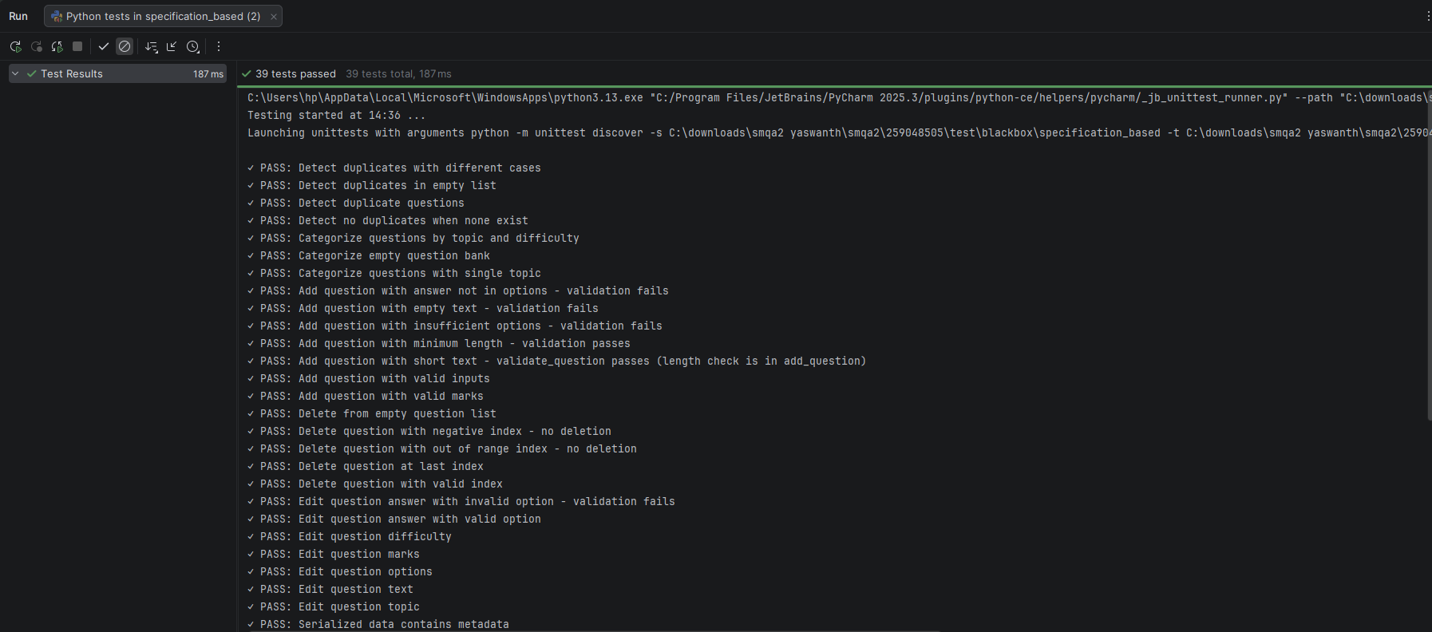
Figure 7: Black-box test execution Outputs of each member

4.3 White-Box Testing
White-box testing examines internal code structure using Python unittest in combination with coverage.py. Structural testing focuses on statement coverage and branch coverage, with coverage execution configured using the branch option to ensure conditional logic paths execute as intended. Statement coverage tests reside under the statement coverage directory, and branch coverage tests reside under the branch coverage directory.
Sheena contributes to white-box testing of validation and decision logic within the question bank module, ensuring that all executable statements and branches related to question validation and categorisation are exercised.
Anjani contributes to white-box testing of exam draft logic, focusing on internal branches associated with mark calculation, difficulty validation, and version handling.
Harsha Vardhan contributes to white-box testing of review decision logic, validating conditional branches related to review status transitions and approval outcomes.
Ak Gy contributes to white-box testing of storage and security logic, validating branches related to encryption, comparison, and backup execution.
All white-box tests execute successfully, and coverage reports generate without errors, indicating correct execution of internal logic under tested conditions.

4.4 Symbolic Execution
Symbolic execution supports reasoning about execution paths by analysing conditions and constraints within the code. Symbolic execution occurs manually through derivation of path conditions from conditional statements, followed by construction of concrete test inputs that satisfy derived constraints. This approach enables systematic exploration of decision-heavy logic without reliance on automated symbolic execution tools.
Symbolic execution targets functions that contain multiple conditional branches, including question validation, draft validation, finalised exam storage, and review status updates. Sheena contributes to symbolic path analysis for question validation logic. Anjani contributes to symbolic analysis of draft validation logic. Harsha Vardhan contributes to symbolic analysis of review status update logic. Ak Gy contributes to symbolic analysis of finalised exam storage logic. Execution of corresponding test cases confirms correct handling of analysed path conditions [5].

4.5 Concolic Testing
Concolic testing combines concrete execution with symbolic reasoning to systematically explore alternative execution paths. Implementation uses Python unittest with iterative constraint manipulation. Path conditions collected during execution guide generation of new test inputs that trigger alternative branches in subsequent runs.
Concolic testing applies to the same decision-intensive functions examined during symbolic execution. Sheena contributes to concolic testing of question validation paths. Anjani contributes to concolic testing of draft validation paths. Harsha Vardhan contributes to concolic testing of review status transition paths. Ak Gy contributes to concolic testing of storage decision paths. All concolic test cases execute successfully and integrate with the unified test discovery workflow, confirming stable behaviour across explored paths [6].

4.6 Test Coverage Measurement
Test coverage measurement uses coverage.py to generate numerical coverage metrics. Coverage execution produces terminal summaries and detailed HTML reports, with coverage aggregated at the module and file level. Coverage measurement does not operate at the per-function level, as module-level granularity provides sufficient insight for verification.
Coverage reports generate only after successful execution of all associated test suites, ensuring that reported metrics reflect stable and verified runs. The generated HTML reports visually indicate covered and uncovered code regions, supporting assessment of test completeness. Numerical coverage measurement complements functional, structural, symbolic, and concolic testing by providing objective evidence of exercised execution paths [4].
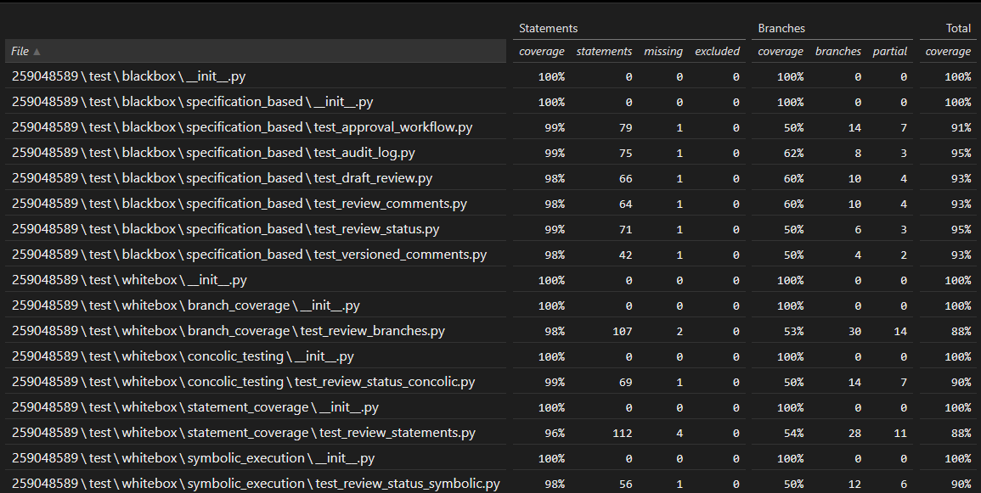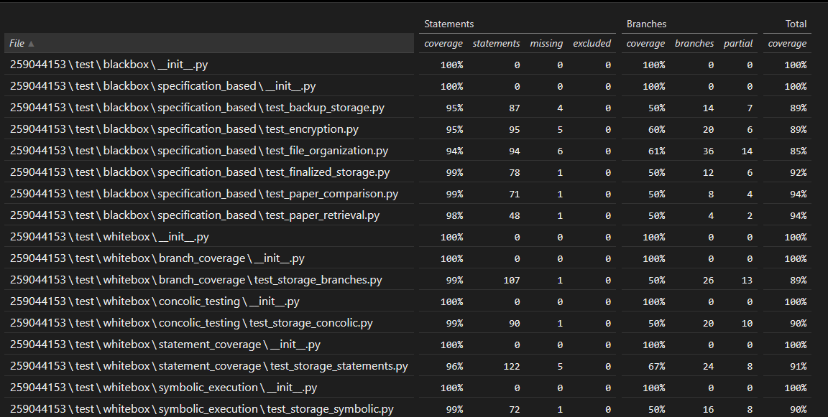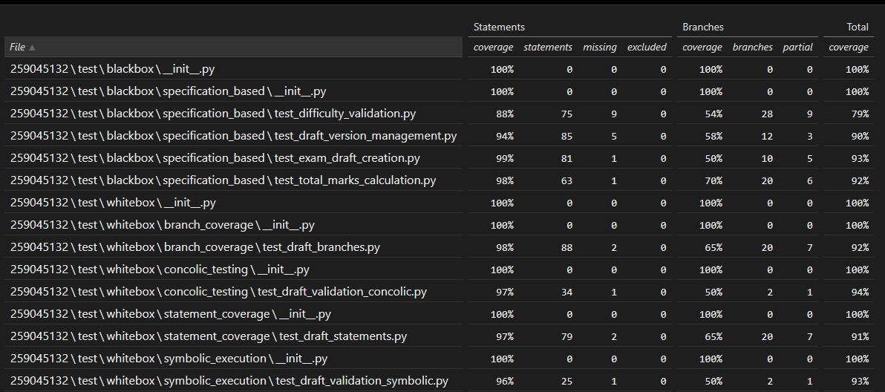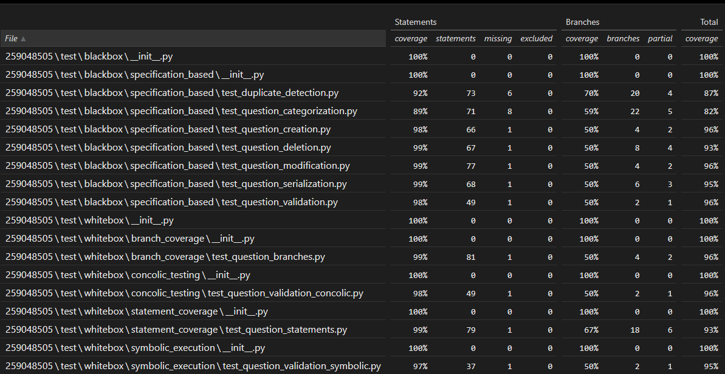
Figure 8: htmlcov/index.html coverages of all team members

CMMI Level 2 Documentation Audit:

Process quality for the Examination Paper Management System aligns with the principles of Capability Maturity Model Integration Level 2, which focuses on establishing basic project management and control practices. The development activities follow defined procedures that ensure requirements traceability, planned execution, monitored progress, controlled configuration, and objective quality assurance. Evidence for each required process area is derived directly from implemented artefacts, sprint planning records, code structure, and supporting logs [7].
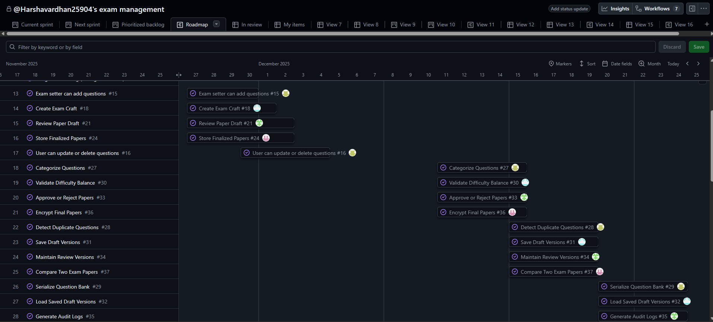
Figure9: Roadmap of Sprints in Github Project
Requirements management ensures that all functional requirements remain clearly defined, tracked, and controlled throughout development. Requirements are expressed as user stories that describe observable system behaviour and map directly to back-end functions. Each user story links to a specific module and function path, enabling verification that implemented functionality satisfies the stated requirement. Changes to requirements follow controlled updates within sprint boundaries, preventing uncontrolled scope expansion and supporting requirement stability [3].
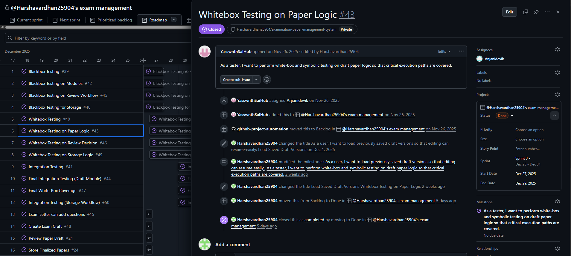
Figure10: Creating User Stories to each team memeber
Project planning establishes a structured approach to scheduling, effort estimation, and task allocation. Sprint plans define development phases with fixed start and end dates. User stories are assigned to individual team members, ensuring accountability and balanced workload distribution. Formal estimation techniques, including PERT analysis and cost estimation models, provide quantitative insight into expected effort and schedule. These planning artefacts demonstrate alignment with defined project objectives and provide a baseline for monitoring progress [1].
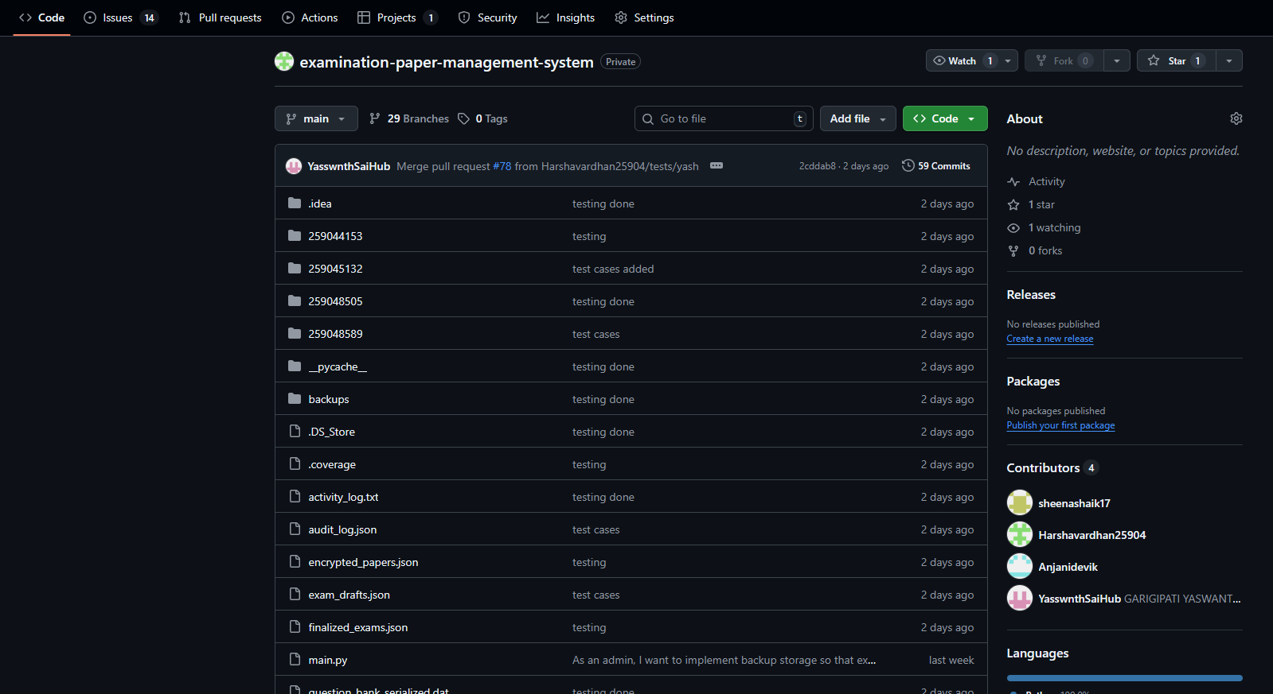
Figure11: Project Repository
Project monitoring and control activities ensure that planned work progresses as expected. Sprint timelines, user story completion status, and activity logs provide visibility into development progress. Deviations from planned schedules are identifiable through sprint tracking and burndown analysis. Monitoring practices support early identification of delays and ensure that corrective action can be applied within subsequent sprint boundaries. These practices reflect controlled execution and adherence to planned objectives [2].
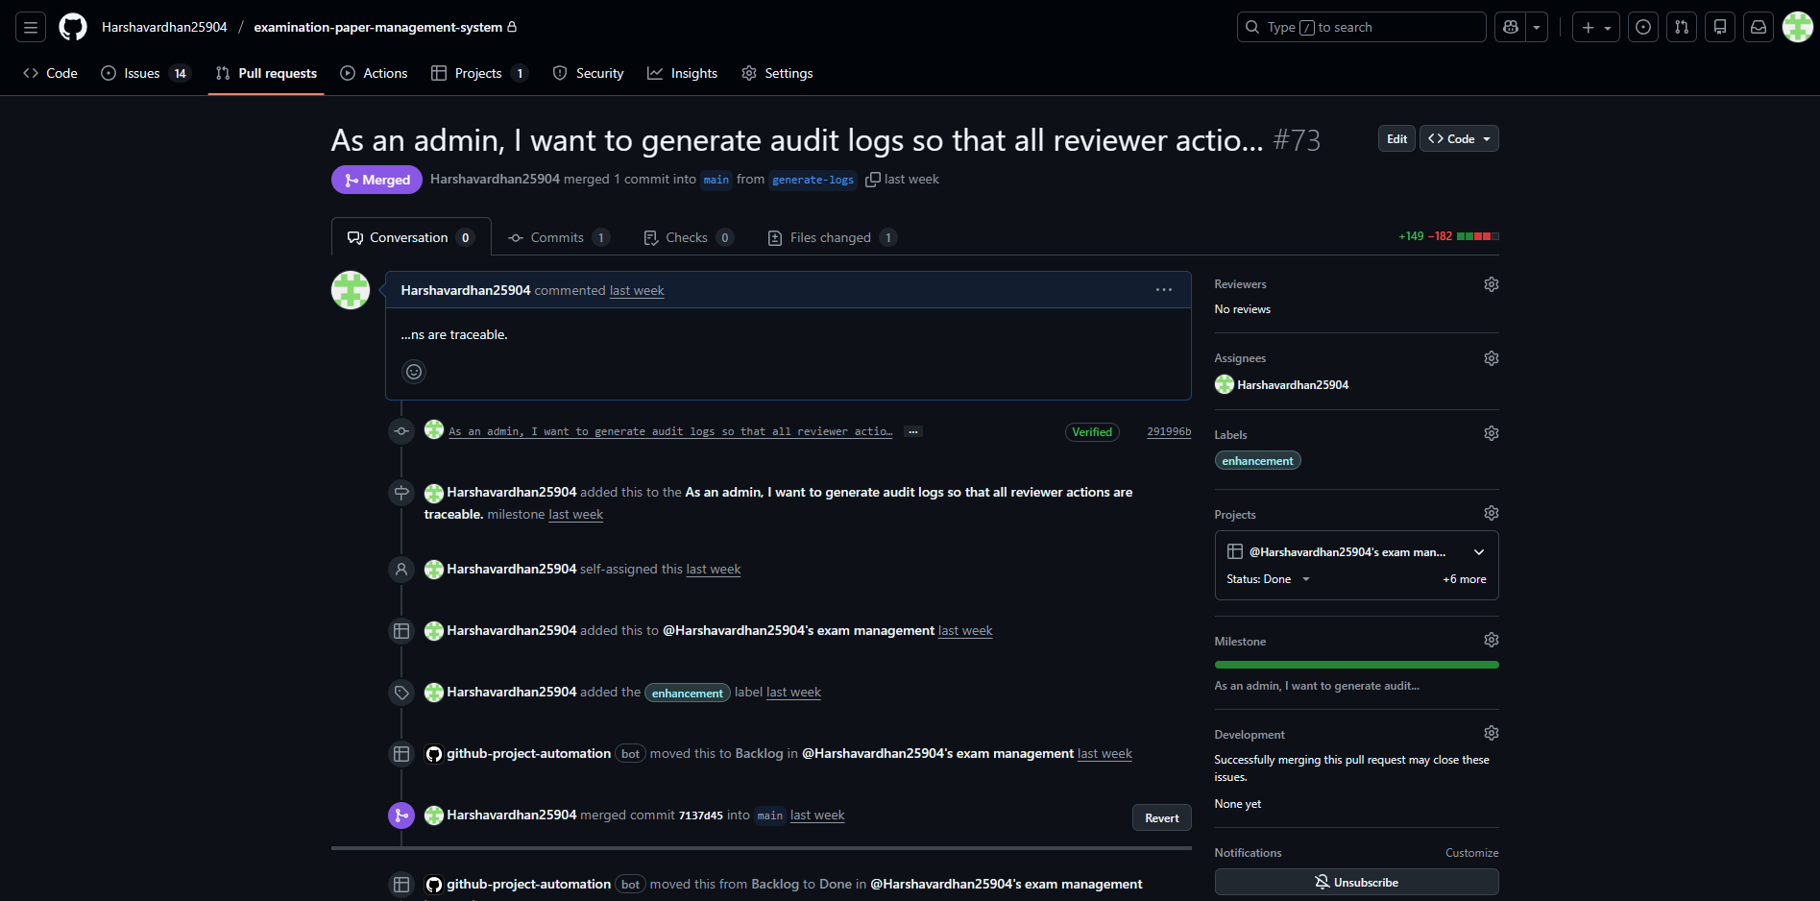
Figure12: Pull Request Process while commit
Configuration management controls changes to software artefacts and ensures consistency across versions. Source code files, data files, and serialized objects are maintained in an organised directory structure. Versioned exam drafts and review records demonstrate controlled modification of critical artefacts. Backup mechanisms preserve historical states of stored data, while restoration functions support recovery. These controls ensure that changes are traceable and reversible, supporting integrity of the software baseline [7].
Measurement and analysis activities provide quantitative insight into project performance and product quality. Metrics such as story point completion, sprint velocity, estimated effort, and cost estimates support objective evaluation of development progress. These measures enable comparison between planned and completed work and support informed decision-making during project execution. The use of formal estimation and measurement techniques reflects disciplined management practice [1].
Process and product quality assurance activities ensure that defined processes are followed and that software outputs meet specified criteria. Validation logic within the back-end enforces data correctness and consistency. Audit logs record key actions and outcomes, providing evidence of compliance with defined workflows. The structured separation of development and testing phases supports objective verification of functionality. These practices demonstrate adherence to quality-focused development principles [7].
The application of CMMI Level 2 process areas establishes a managed development environment for the Examination Paper Management System. Requirements remain traceable, planning activities remain structured, progress remains observable, configuration remains controlled, and quality assurance remains integral to development. This alignment supports predictable outcomes and demonstrates disciplined software engineering practice consistent with recognised process maturity models [3], [8].

Conclusion

The Examination Paper Management System demonstrates a structured application of software engineering principles through disciplined planning, systematic design, controlled implementation, and process-oriented quality management. The back-end implementation supports the complete lifecycle of examination paper handling, including question management, exam drafting, review workflows, secure storage, encryption, backup, and audit logging. Modular design and file-based persistence ensure transparency of data flow and traceability of functionality, supporting correctness and maintainability within an academic context [3].
Software planning activities establish clear alignment between requirements and implementation. User stories define functional scope and map directly to back-end functions, enabling precise verification of delivered capabilities. Sprint-based scheduling supports incremental development, while formal estimation techniques provide realistic insight into effort, schedule, and cost. The application of PERT analysis identifies dependencies and critical activities, and cost estimation using recognised models supports informed planning and control [1].
Process maturity considerations reinforce disciplined execution. Alignment with CMMI Level 2 process areas ensures that requirements remain managed, planning remains structured, progress remains observable, configuration remains controlled, and quality assurance remains integral to development activities. Evidence derived from code structure, logs, versioned artefacts, and planning records demonstrates adherence to managed process practices and supports objective evaluation of project outcomes [7].
Overall, the system reflects consistent application of taught software engineering concepts, combining practical implementation with formal planning and process control. The outcomes illustrate how structured methods contribute to predictable delivery, traceable functionality, and controlled quality within a software development project [4], [8].

Section B – Introduction
Section B focuses on the organisation of development work and the contribution of team members involved in the Examination Paper Management System. Effective team structure and clear responsibility allocation support coordinated development, reduce overlap of work, and ensure accountability for delivered functionality. Team-based development aligns with established software engineering practice, where structured collaboration contributes to predictable outcomes and controlled execution of project activities [3].
The project adopts a collaborative working model in which responsibilities are distributed across defined functional areas. Each team member contributes to specific components of the back-end system while maintaining alignment with overall project objectives. Sprint-based planning provides a framework for coordinating individual contributions within fixed time boundaries. This approach supports visibility of progress, balanced workload distribution, and traceability between assigned tasks and implemented functionality [2].
Team coordination activities ensure that development tasks align with planned schedules and dependencies identified during software planning. User stories act as the primary mechanism for defining work units and assigning responsibility. Mapping user stories to individual team members establishes clear ownership of system components and simplifies verification of contributions. This structure supports disciplined project execution and aligns with recommended practices for managed software development [1].
The focus on defined roles and structured collaboration supports both technical quality and process maturity. Clear team organisation enables effective implementation of planning artefacts such as sprint schedules, PERT activities, and cost estimation models. This alignment between team structure and planning mechanisms reinforces controlled development and contributes to measurable project performance [7].

Team Structure
The team structure for the Examination Paper Management System follows a functional allocation model that supports clarity of responsibility and controlled coordination of development activities. Each team member holds defined responsibilities that align with specific functional areas of the back-end system. This structure supports traceability between assigned work, implemented functions, and planned user stories, which is a key requirement for managed software development [1].
Sheena contributes to the question bank component, which forms the foundation of the examination workflow. Responsibilities include question creation, modification, validation, categorisation by topic and difficulty, duplicate detection, and serialization of question data. These activities support reliable question reuse and ensure that only valid and structured content enters later stages of the system. Clear ownership of this module reduces ambiguity and supports consistent data handling across the system [3].
Anjani contributes to the exam draft management component, which focuses on assembling examination papers from validated questions. Responsibilities include draft creation, metadata handling, automatic mark calculation, difficulty balance validation, version control, and draft retrieval. This role ensures that examination papers remain structured, traceable across versions, and consistent with defined academic requirements. Allocation of these responsibilities supports controlled evolution of exam drafts and reduces the risk of version conflicts [4].
Harsha Vardhan performs sprint planning and coordination activities, supporting alignment between development tasks and planned schedules. Responsibilities include organising user stories across sprints, tracking progress against sprint timelines, and ensuring consistency between planning artefacts and implemented functionality. This role supports disciplined execution by maintaining visibility of task dependencies and alignment with planned milestones, which is essential for effective project monitoring and control [2].
Ak Gy contributes to system support and integration activities across modules. Responsibilities include assisting with implementation tasks, supporting integration between functional components, and participating in validation activities during the testing phase. This role supports overall system stability by ensuring that individual modules interact correctly and that integration issues are identified and resolved in a timely manner [3].
The defined team structure supports balanced workload distribution and clear accountability. Functional ownership enables focused development within modules while maintaining alignment with overall system objectives. This organisation reflects recommended practices for small team software development, where clear responsibility boundaries and structured coordination contribute to predictable outcomes and controlled quality [7].

Team Contribution and Reflection
Team contribution within the Examination Paper Management System reflects coordinated effort aligned with defined roles, planned user stories, and scheduled sprints. Each team member contributes to system development and quality activities in accordance with assigned responsibilities. Contribution evidence is observable through implemented back-end functions, structured data files, sprint artefacts, and documented workflows. This alignment between planned work and implemented outcomes supports traceability and accountability, which are essential characteristics of managed software development [1].
Sheena’s contribution focuses on establishing and stabilising the question bank component. Activities include implementing question creation, modification, validation, categorisation, duplicate detection, and serialization. These functions ensure that examination content remains structured, reusable, and consistent across the system. Contribution to this component supports reliability of downstream processes such as exam draft creation and review. The work demonstrates application of modular design principles and validation logic to enforce data correctness [3].
Anjani’s contribution centres on exam draft management and version control. Activities include implementing draft creation logic, metadata handling, automatic mark calculation, difficulty balance validation, and management of multiple draft versions. These contributions ensure controlled evolution of examination papers and support traceability of changes across revisions. The work reflects structured handling of complex data objects and demonstrates disciplined management of functional dependencies within the back-end system [4].
Harsha Vardhan’s contribution focuses on sprint planning and coordination. Activities include organising user stories across sprints, aligning tasks with sprint goals, and ensuring consistency between planning artefacts and implementation outcomes. This contribution supports effective scheduling, progress tracking, and dependency management. The role strengthens project control by maintaining alignment between planned activities and completed work, which is a key requirement for managed process execution [2].
Ak Gy’s contribution supports system integration and overall stability. Activities include assisting with implementation tasks, supporting interaction between modules, and participating in validation during the testing phase. This contribution helps ensure that individual components function cohesively within the complete system. Integration-focused support reduces the risk of functional mismatches and strengthens system reliability [3].
Overall reflection on team contribution highlights the effectiveness of role-based allocation and sprint-driven execution. Clear ownership of functional areas supports focused development, while coordinated planning ensures alignment with project objectives. The collective contribution demonstrates practical application of software engineering principles related to modular design, planned execution, and quality-oriented development. This outcome aligns with recommended practices for small-team software projects and supports predictable delivery and controlled quality [7], [8].

References

[1] Boehm, B. W. (1981). Software engineering economics. Prentice Hall.
https://ieeexplore.ieee.org/document/1702375
[2] Project Management Institute. (2017). A guide to the project management body of knowledge (PMBOK Guide) (6th ed.). Project Management Institute.
https://www.pmi.org/pmbok-guide-standards
[3] Sommerville, I. (2016). Software engineering (10th ed.). Pearson Education.
https://www.pearson.com/en-gb/subject-catalog/p/software-engineering/P200000006375
[4] Pressman, R. S., & Maxim, B. R. (2020). Software engineering: A practitioner’s approach (9th ed.). McGraw-Hill Education.
https://www.mheducation.com/highered/product/software-engineering-practitioner-s-approach-pressman/M9781260548006.html
[5] King, J. C. (1976). Symbolic execution and program testing. Communications of the ACM, 19(7), 385–394.
https://doi.org/10.1145/360248.360252
[6] Sen, K., Marinov, D., & Agha, G. (2005). CUTE: A concolic unit testing engine for C. ACM SIGSOFT Software Engineering Notes, 30(5), 263–272.
https://doi.org/10.1145/1095430.1081750
[7] Carnegie Mellon Software Engineering Institute. (2010). CMMI for Development, Version 1.3.
https://resources.sei.cmu.edu/library/asset-view.cfm?assetid=9665
[8] IEEE Computer Society. (2014). Guide to the software engineering body of knowledge (SWEBOK Guide), Version 3.0.
https://www.computer.org/education/bodies-of-knowledge/software-engineering

